Assignment - 1 Simple CPU Design using Verilog
A Lab Report submitted by
Palak Mishra
B24EE1050


Indian Institute of Technology Jodhpur

Objective :
The goal of this project is to create and validate a compact CPU system using Verilog HDL and Xilinx Vivado. This system features a 16-entry instruction memory, a combinational CPU/ALU that can perform six distinct operations, and an integrated processor that links the instruction memory with the CPU. The entire design is confirmed through behavioral simulation in Vivado.

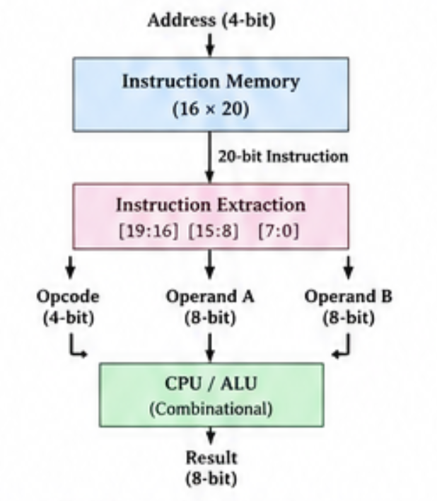

Memory Specification :
Parameter | Specification
Number of locations | 16
Address width | 4 bits
Instruction width | 20 bits
Read | Combinational
Write | Synchronous
Write enable | we

Instruction Format :
20-bit instruction
Opcode | Operand 1 | Operand 2
4 bits | 8 bits | 8 bits

Opcode table :
Opcode | Operation
0000 | ADD
0001 | SUB
0010 | AND
0011 | OR
0100 | XOR
0101 | MUL
Others | Result = 0

Memory initialisation table :
Address | Instruction
0 | ADD 10, 20
1 | SUB 30, 5
2 | AND 15, 7
3 | OR 12, 3
4 | XOR 10, 5
5 | MUL 6, 7

Source Code : https://github.com/palakmishra01/COA_LAB/tree/main

Vivado simulation result :
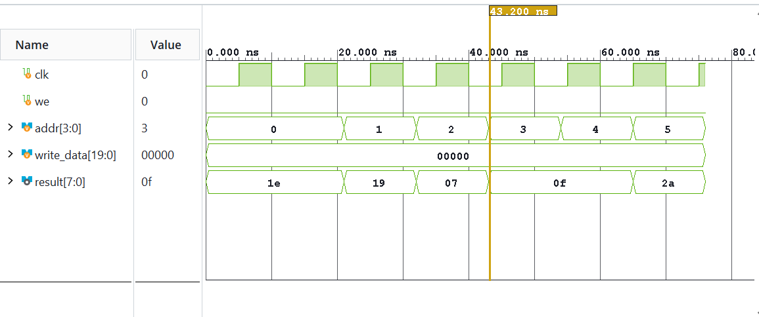
Data path : Address -> Instruction Memory -> 20-bit Instruction -> Instruction Extraction -> Opcode + Operand A + Operand B -> CPU / ALU -> 8-bit Result

Console log :
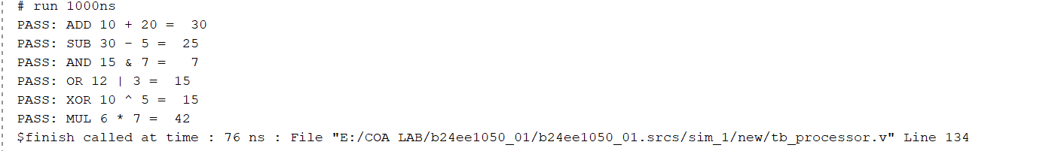

Conclusion :
The integrated processor, the combinational CPU/ALU, and the 16-entry instruction memory were successfully implemented using Verilog HDL in Xilinx Vivado. The ADD, SUB, AND, OR, XOR, and MUL operations were checked by means of the integrated testbench, and all six test cases produced the expected results, which shows that the entire processor datapath functioned correctly.

